**Start Pattern**

**Send Feedback**

Print the following pattern

**Pattern for N = 4**

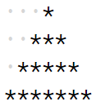

The dots represent spaces.

**Input Format :**

N (Total no. of rows)

**Output Format :**

Pattern in N lines

**Constraints :**

0 <= N <= 50

**Sample Input 1 :**

3

**Sample Output 1 :**

*

***

*****

**Sample Input 2 :**

4

**Sample Output 2 :**

*

***

*****

*******